Cinex Manager: Installation Guide
1. Source Code Setup
- Clone the project: Open your Command Prompt (CMD) and run the following command: git clone https://github.com/lbg-globagility/cinex-manager.git
- Configure the Database: Navigate to the Cinemapps folder. Locate the file app.debug.config and update it with the correct database connection strings.
- 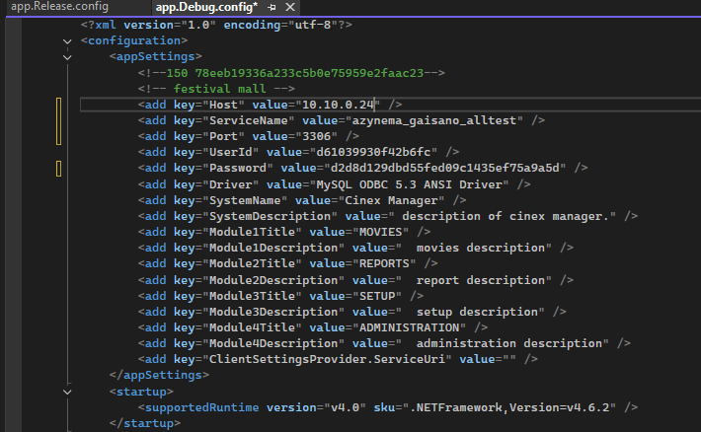
- <add key="UserId" value="d61039930f42b6fc" />
"d61039930f42b6fc" is equivalent to "root"
- <add key="Password" value="d2d8d129dbd55fed09c1435ef75a9a5d" />
"d2d8d129dbd55fed09c1435ef75a9a5d" is equivalent to "Am3L74rS"
Note: Currently, the decipher code for `UserId` and `Password` is not yet documented that is why when setting up (even the initial setup) the database server to any cinex clients got to use the same `UserId` & `Password` mentioned above.
2. Build and Package
- Rebuild Solution: Open the solution in your IDE and perform a Rebuild All to ensure every project compiles correctly.
- Create Deployment Zip: Navigate to Cinemapps/bin/Debug. Compress the entire Debug folder into a file named debug.zip.
3. Deployment and Installation
- Transfer Files: Upload debug.zip to the target deployment PC.
- Extract and Install: Unzip the folder, locate Cinemapps.exe, and run it to begin the installation.
4. Required Dependencies
Download and install the following components from this Google Drive Folder:
- mysql-connector 6.9.8.msi
- mysql-connector-odbc (Select 32-bit or 64-bit depending on the system architecture)
- mysql-essential (for server only)
- vcredist_x86.exe (Visual C++ Redistributable Packages for Visual Studio 2013)
- setuprdproject.msi
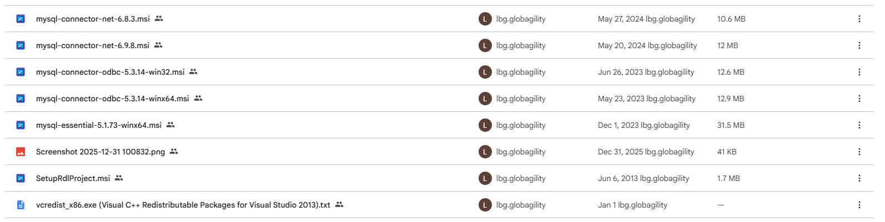
5. Final Configuration
- Testing: Launch the application and verify that all functions and reports are working correctly.
- Desktop Shortcut: Create a shortcut for the application and move it to the Desktop for easy access.

